[Fake news Detection]

[17]

Team Members:

1. Amgad Abd el Baset 20191700132 **امجد عبد الباسط**

2. Andrew Nassef Amin 20191700144 **اندرو ناصف امين**

3. Andre Adel Ibrahim 20191700145 **اندرية عادل ابراهيم**

4. Maria Maurice Ayoub 20191700473 **ماريا موريس ايوب**

5. Mayve Ihab Rasmy 20191700485 **مايفى ايهاب رسمى**

6. Mina Samy Anwar 20191700676 **مينا سامى انور**

Fake News Detection

Introduction:

The project main idea is that we have news, and our objective is to detect the fake news from the real ones.

Methodology:

Methodologies Used:

1. Preprocessing:
   * Feature Encoding.
   * Removing stop words.
   * Removing unnecessary text (Using Regular Expressions).
   * Tokenization (Using Word_Tokenize).
   * Lemmatizing (Using WordNetLemmatizer).
2. Feature Extraction (Using TF-IDF).
3. Modelling:
   * Naïve Bayes.
   * Logistic Regression.
   * SVM.
   * Decision Tree.

Data Set Summary:

1. News dataset was used.
2. Columns of dataset:
   * Column 1: random numbers attached to the news.
   * Title Column: contains the title of the news.
   * Text Column: contains the text body of the news.
   * Label Column: contains whether the news is real or fake.
3. Dataset Visualization:
   * Comparison between number of fake news and real news visualization: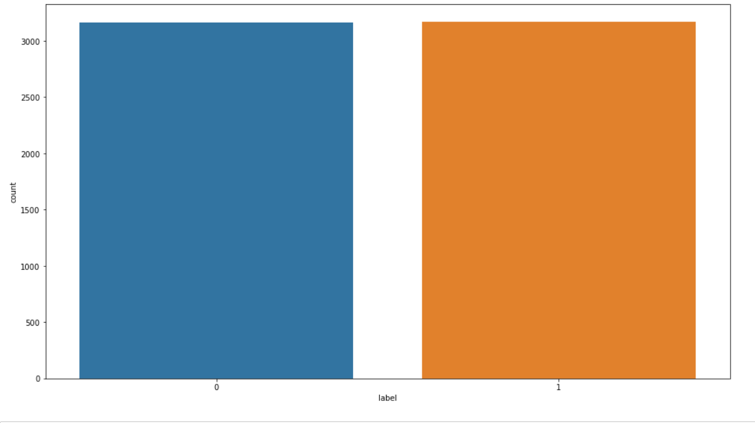
   * 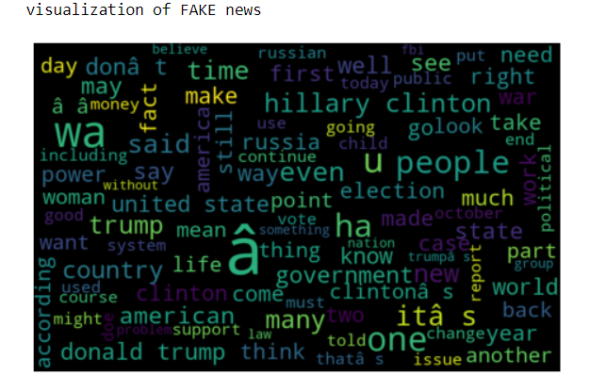

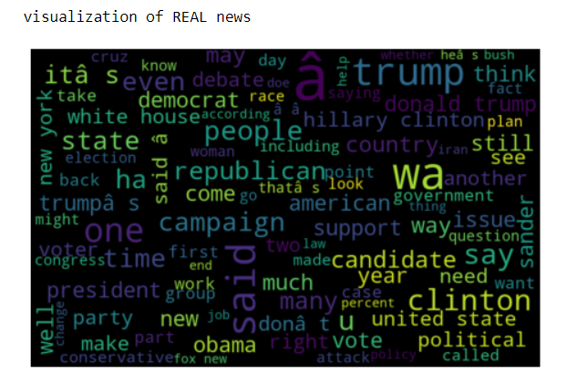

Results:

1. 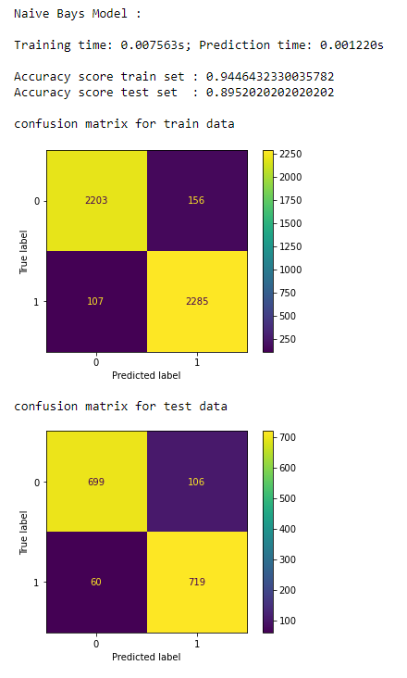
2. 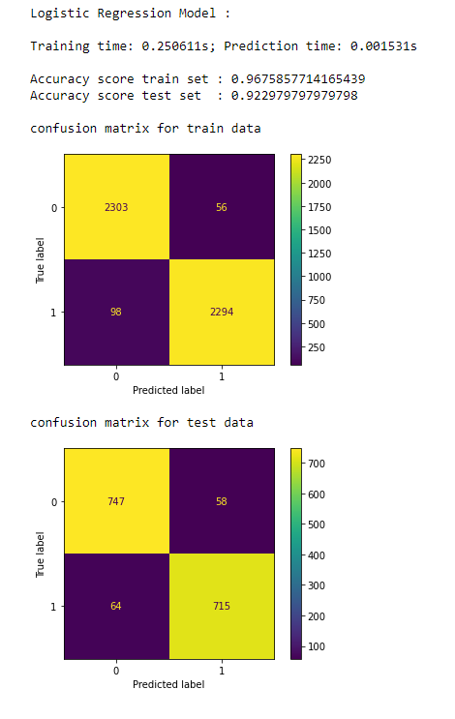
3. 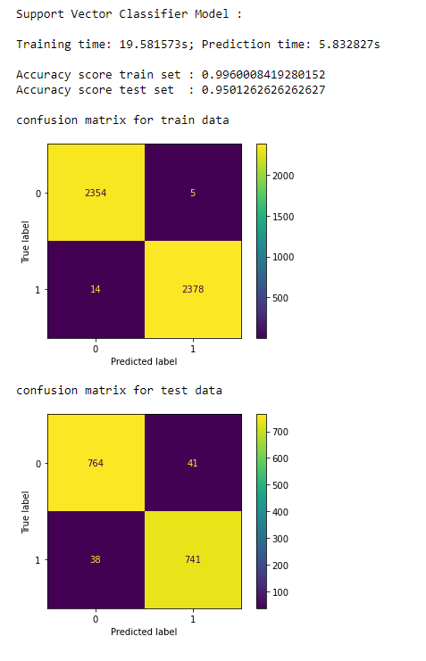
4. 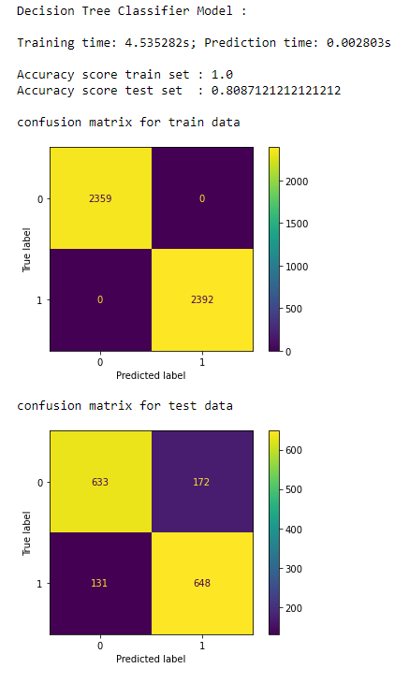
5. 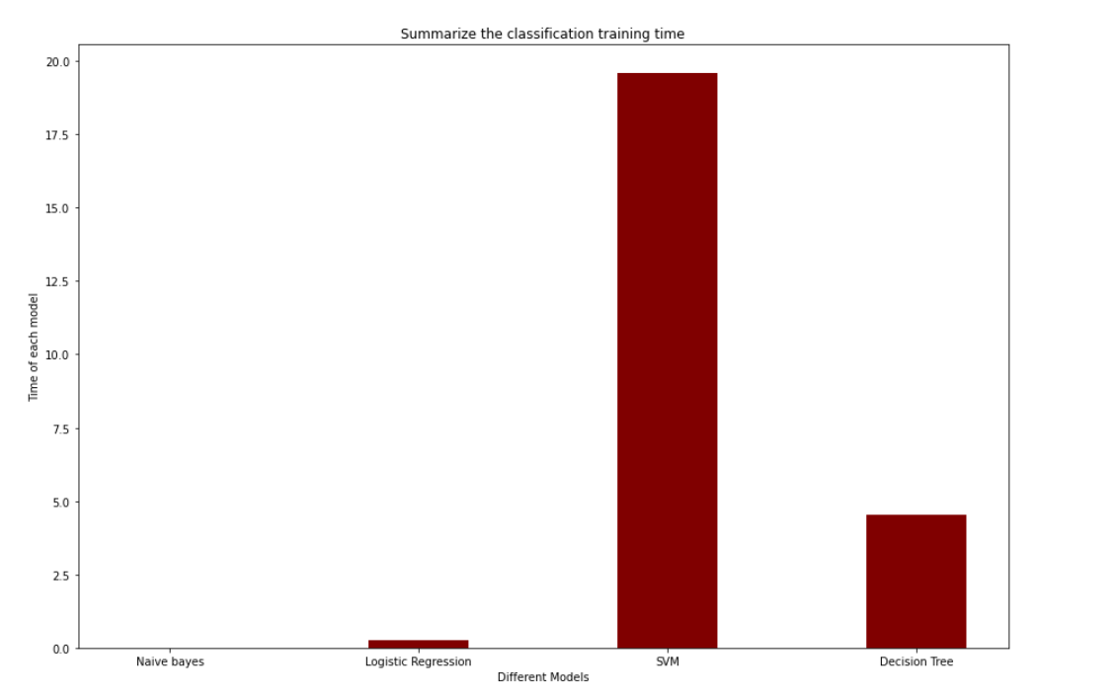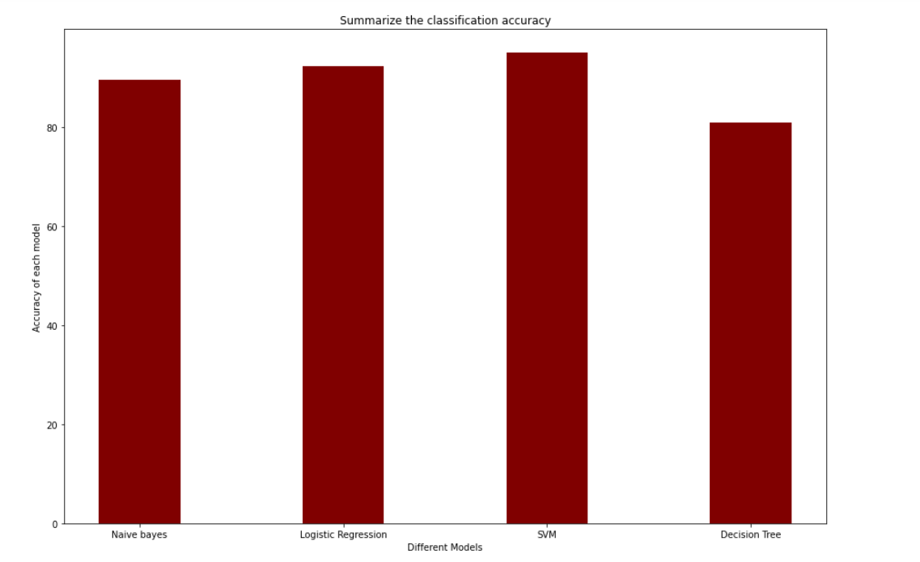Modeling Summary: